EXPERIMENT I

AIM :
To understand the fundamentals of Python programming by creating and manipulating data using the Pandas library, enabling efficient organization and analysis of tabular datasets.

Algorithm:
Import the required Python libraries, including Pandas.
Create a dataset containing sample records.
Convert the dataset into a Pandas DataFrame.
Assign appropriate column names to the DataFrame.
Display the complete DataFrame.
Perform basic inspection of the dataset.
Observe the output for further analysis and visualization.

Program:

import pandas as pd

import numpy as np

import matplotlib.pyplot as plt

from sklearn.preprocessing import MinMaxScaler, LabelEncoder

# --- 1. Load Dataset ---

df = pd.read_csv("pbp2026.csv")

print("=" * 80)

print("FIRST 5 ROWS")

print("=" * 80)

print(df.head())

print("\n" + "=" * 80)

print("LAST 5 ROWS")

print("=" * 80)

print(df.tail())

print("\nDataset Shape :", df.shape)

# --- 2. Check Missing Values ---

print("\n" + "=" * 80)

print("MISSING VALUES")

print("=" * 80)

print(df.isnull())

print("\n" + "=" * 80)

print("COUNT OF MISSING VALUES")

print("=" * 80)

print(df.isnull().sum())

# --- 3. Fill Missing Values ---

print("\n" + "=" * 80)

print("REPLACING MISSING VALUES")

print("=" * 80)

numeric_cols = df.select_dtypes(include=np.number).columns

categorical_cols = df.select_dtypes(include=["object", "string"]).columns

# Fill numerical columns with Mean

for col in numeric_cols:

df[col] = df[col].fillna(df[col].mean())

# Fill categorical columns with Mode

for col in categorical_cols:

df[col] = df[col].fillna(df[col].mode()[0])

print("Missing Values After Filling:\n")

print(df.isnull().sum())

# --- 4. Handle Duplicate Records ---

print("\n" + "=" * 80)

print("DUPLICATE RECORDS")

print("=" * 80)

duplicates = df.duplicated().sum()

print("Duplicate Rows Before Removal :", duplicates)

df.drop_duplicates(inplace=True)

print("Duplicate Rows After Removal :", df.duplicated().sum())

print("Dataset Shape :", df.shape)

# --- 5. Outlier Detection (IQR) ---

print("\n" + "=" * 80)

print("OUTLIER DETECTION")

print("=" * 80)

numeric_columns = ["period", "h_pts", "a_pts", "x", "y", "dist"]

for col in numeric_columns:

Q1 = df[col].quantile(0.25)

Q3 = df[col].quantile(0.75)

IQR = Q3 - Q1

lower = Q1 - 1.5 * IQR

upper = Q3 + 1.5 * IQR

outliers = df[(df[col] < lower) | (df[col] > upper)]

print(f"{col} : {len(outliers)} Outliers")

plt.figure(figsize=(8, 5))

plt.boxplot(df["dist"])

plt.title("Box Plot of Shot Distance (dist)")

plt.ylabel("Distance (ft)")

plt.grid(True)

plt.show()

# --- 6. Min-Max Normalization ---

print("\n" + "=" * 80)

print("MIN-MAX NORMALIZATION")

print("=" * 80)

scaler = MinMaxScaler()

columns_to_normalize = ["period", "h_pts", "a_pts", "x", "y", "dist"]

df[columns_to_normalize] = scaler.fit_transform(df[columns_to_normalize])

print(df[columns_to_normalize].head())

plt.figure(figsize=(8, 5))

plt.hist(df["dist"], bins=30)

plt.title("Normalized Shot Distance (dist)")

plt.xlabel("Distance")

plt.ylabel("Frequency")

plt.grid(True)

plt.show()

# --- 7. Label Encoding ---

print("\n" + "=" * 80)

print("LABEL ENCODING")

print("=" * 80)

label_columns = df.select_dtypes(include=["object", "string"]).columns

encoder = LabelEncoder()

for col in label_columns:

df[col] = encoder.fit_transform(df[col])

print(df.head())

# --- 8. One-Hot Encoding ---

print("\n" + "=" * 80)

print("ONE HOT ENCODING")

print("=" * 80)

onehot_columns = ["team", "type", "result"]

df_onehot = pd.get_dummies(df, columns=onehot_columns, dtype=int)

print(df_onehot.head())

# --- 9. Final Dataset Info & Export ---

print("\n" + "=" * 80)

print("FINAL CLEANED DATASET")

print("=" * 80)

print(df.head())

print("\n" + "=" * 80)

print("DATASET INFORMATION")

print("=" * 80)

print(df.info())

print("\n" + "=" * 80)

print("STATISTICAL SUMMARY")

print("=" * 80)

print(df.describe())

df.to_csv("pbp2026_Cleaned.csv", index=False)

print("\nCleaned dataset saved successfully as 'pbp2026_Cleaned.csv'")

Output:

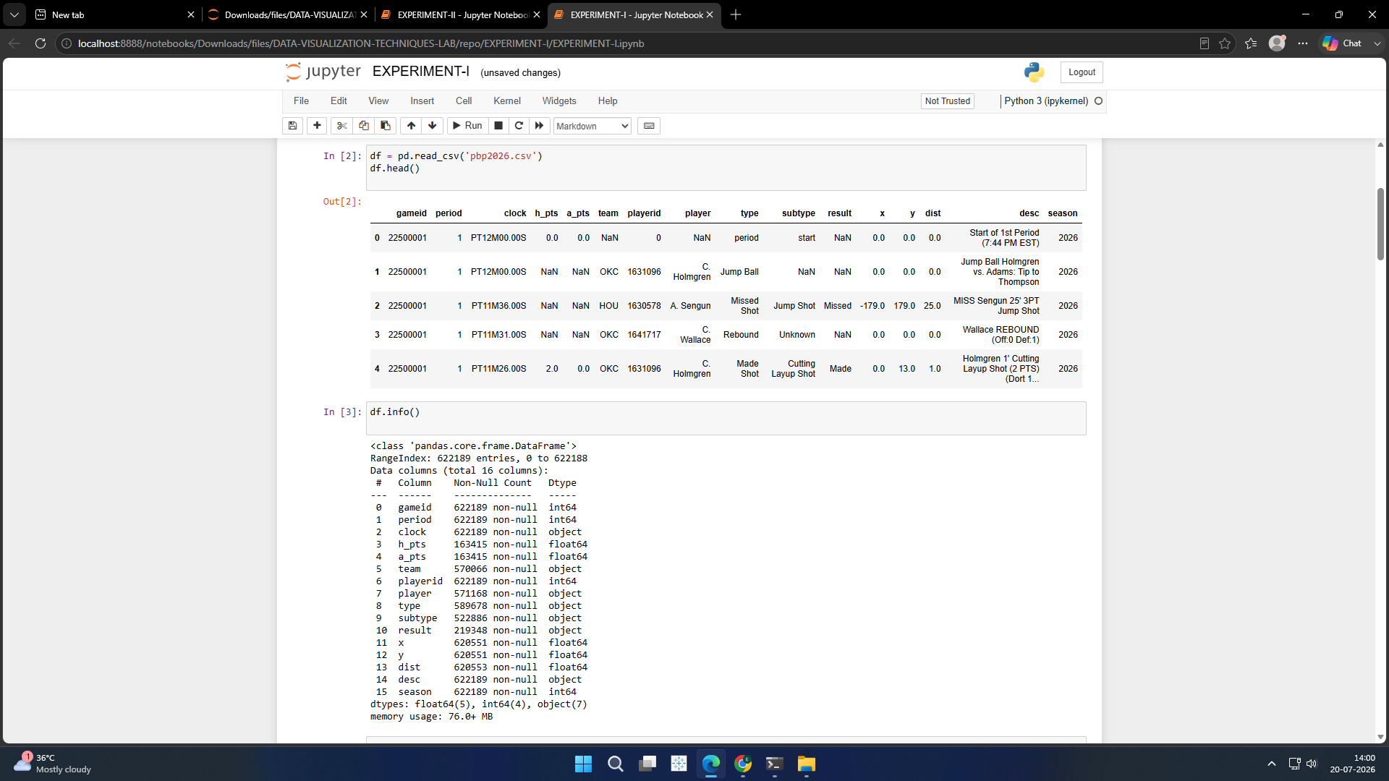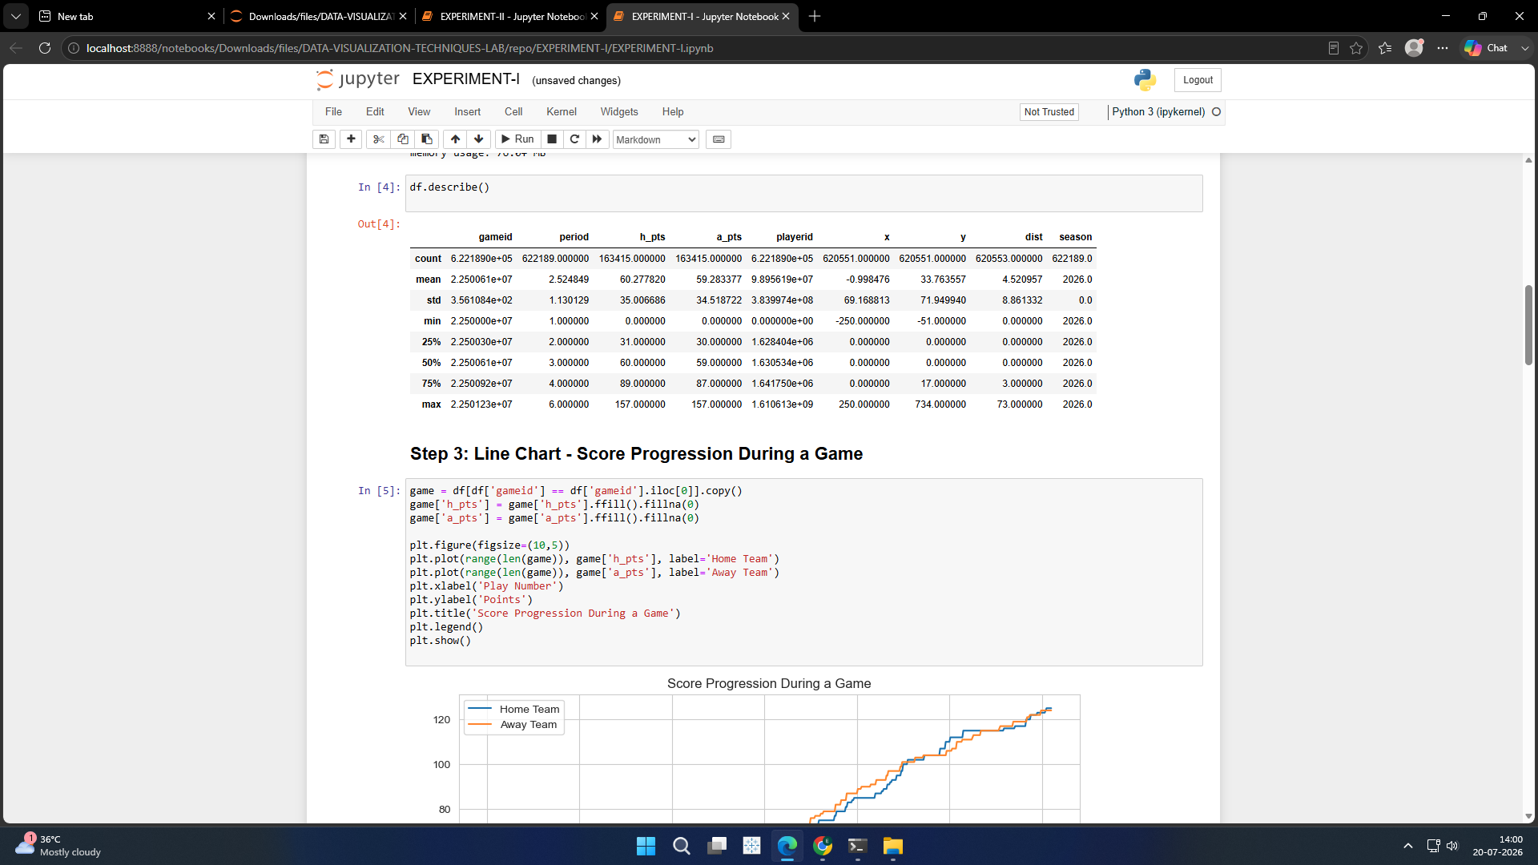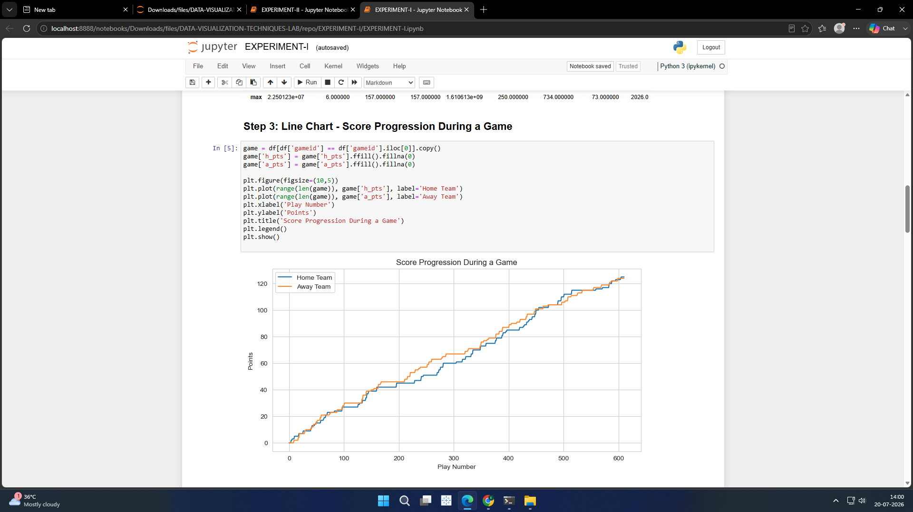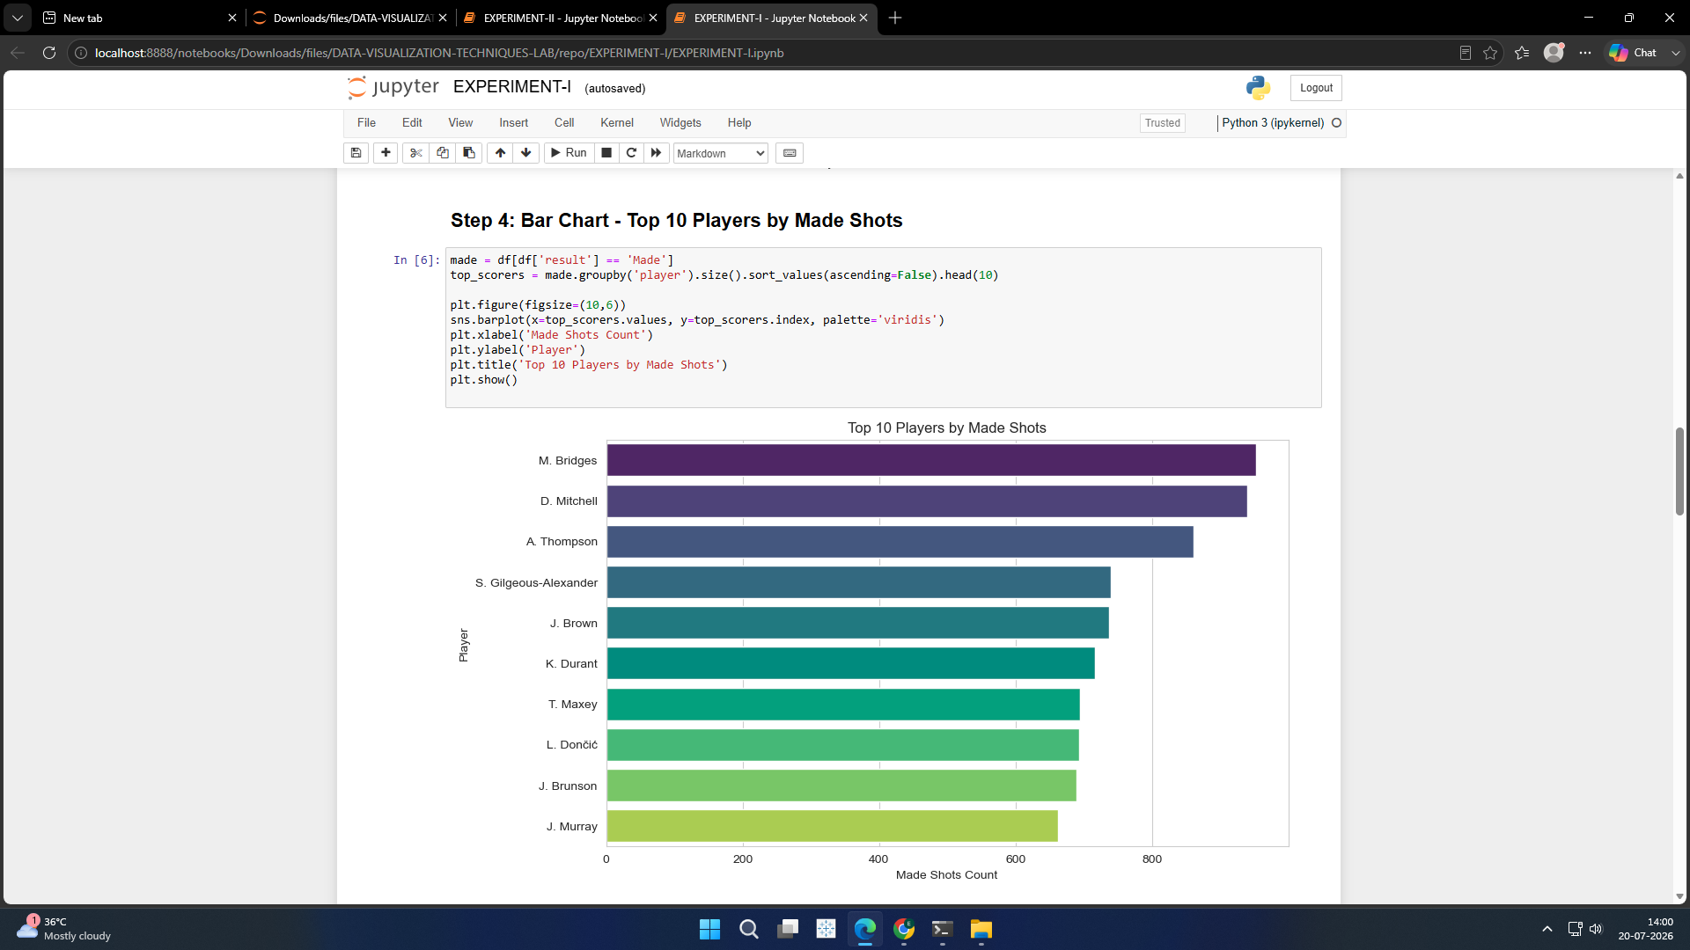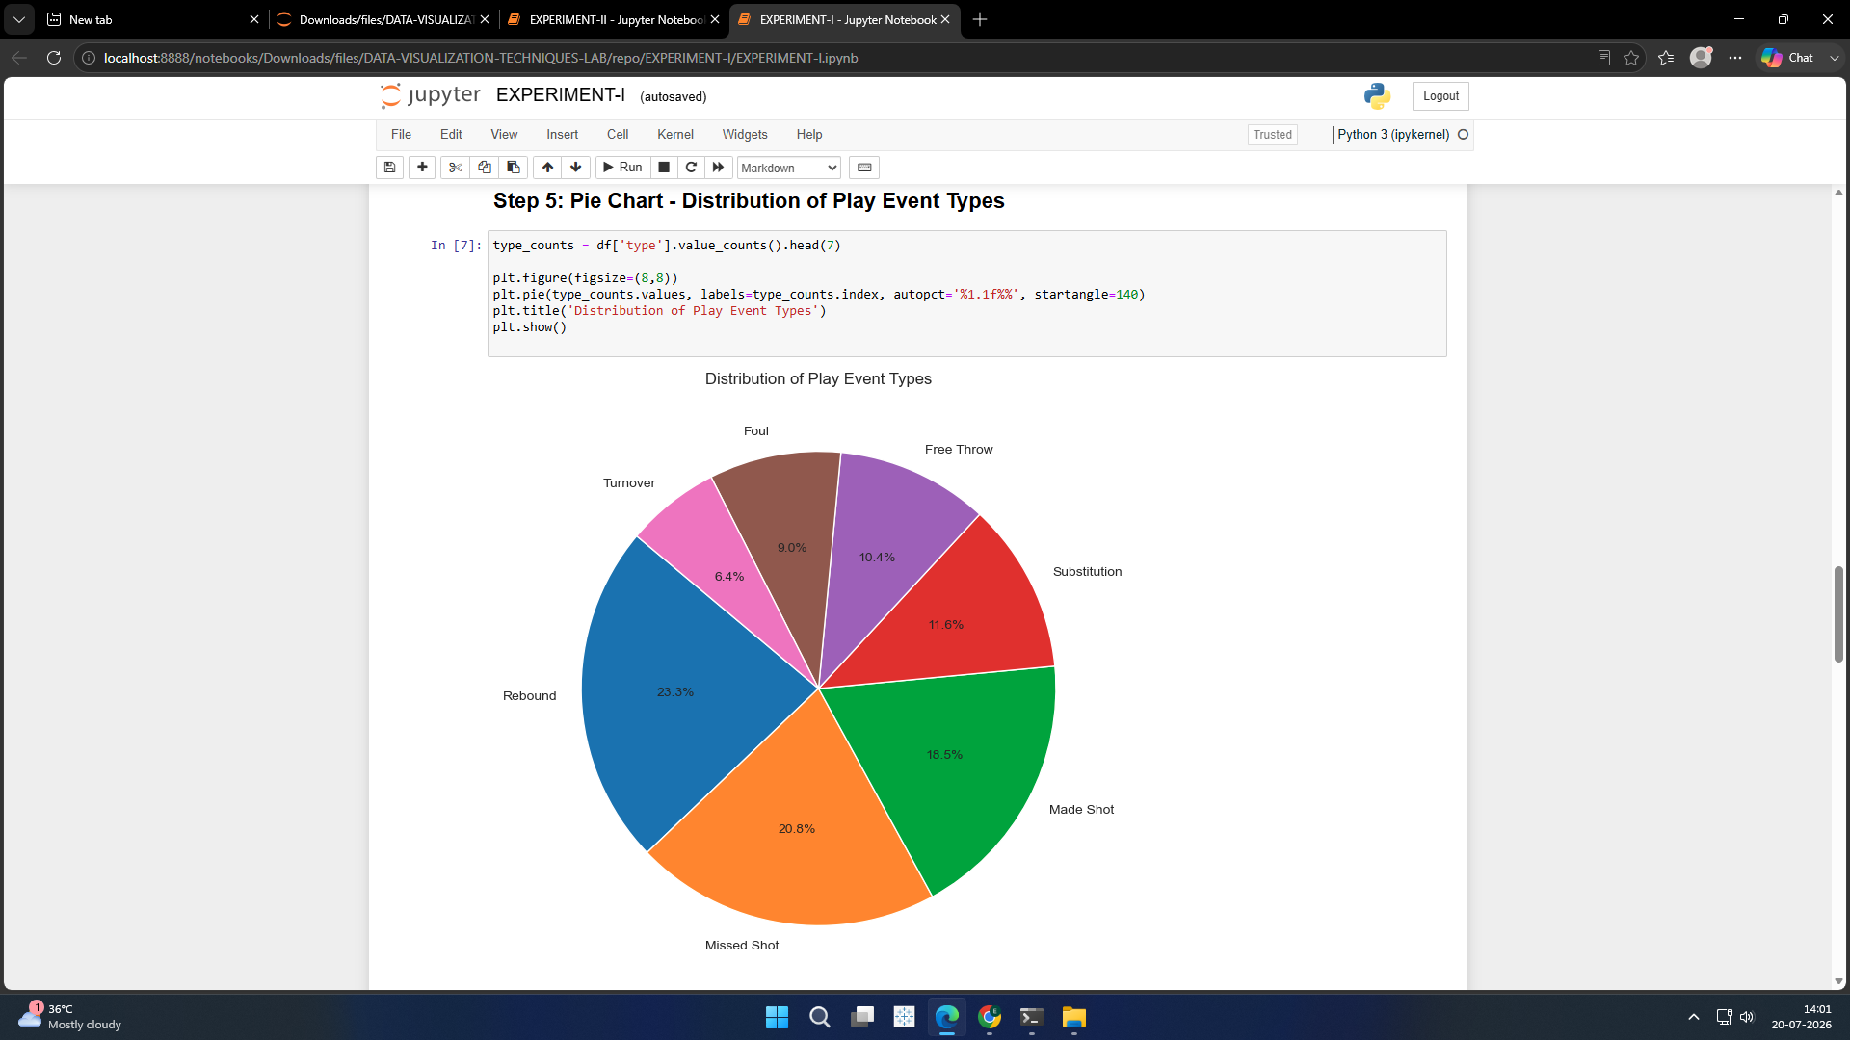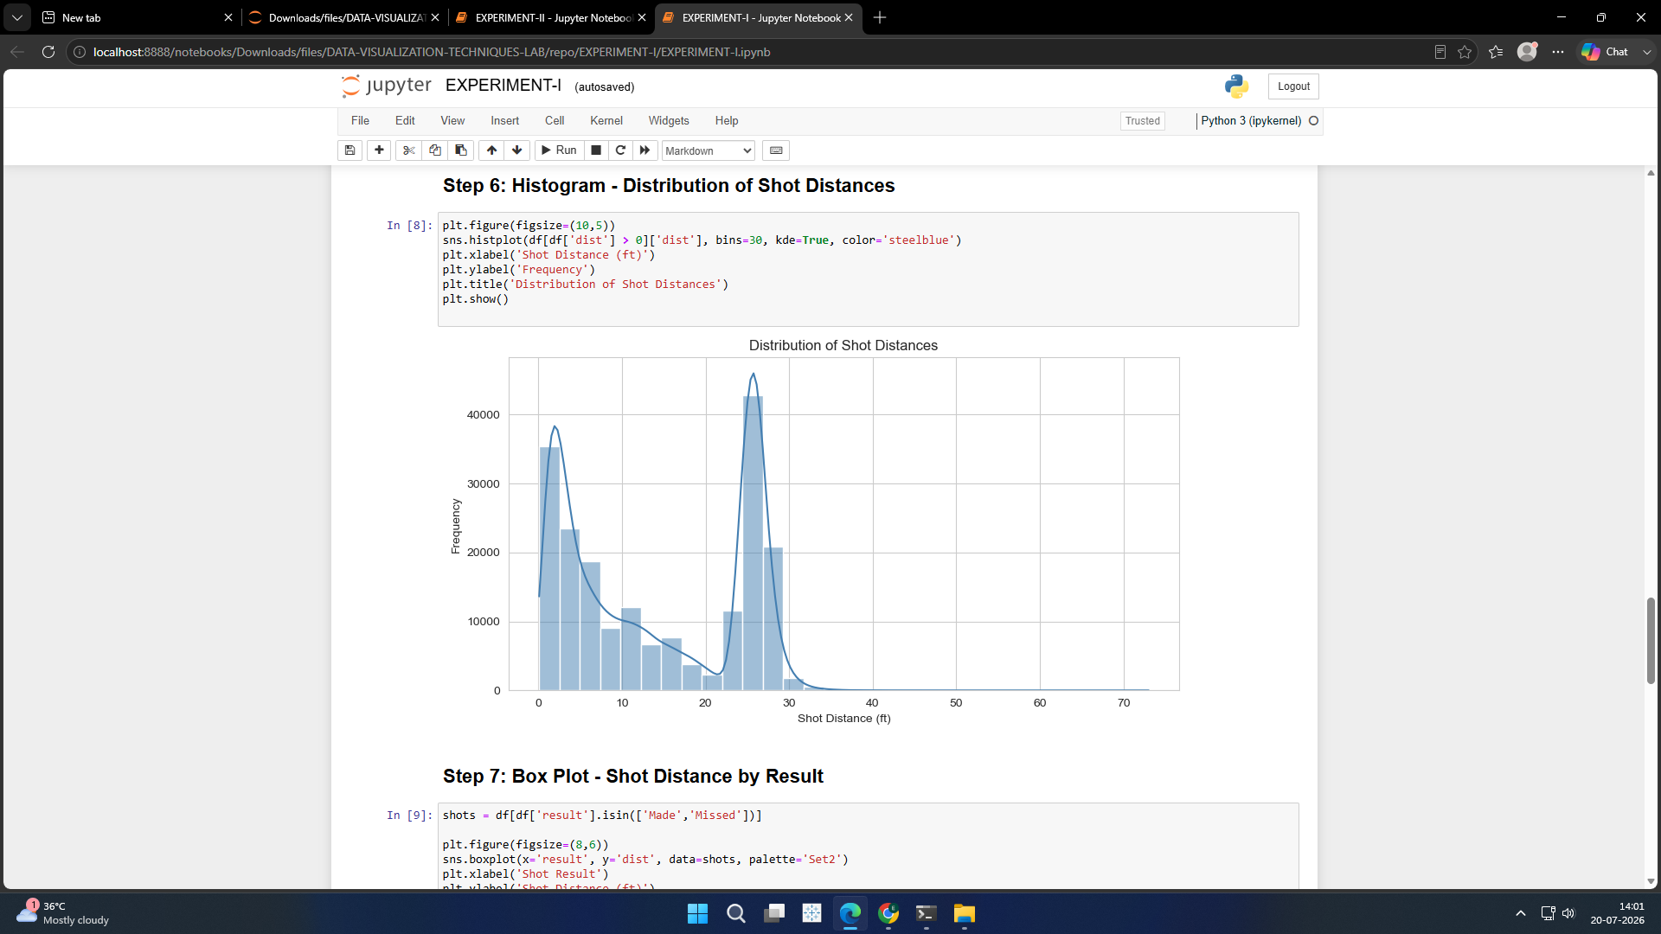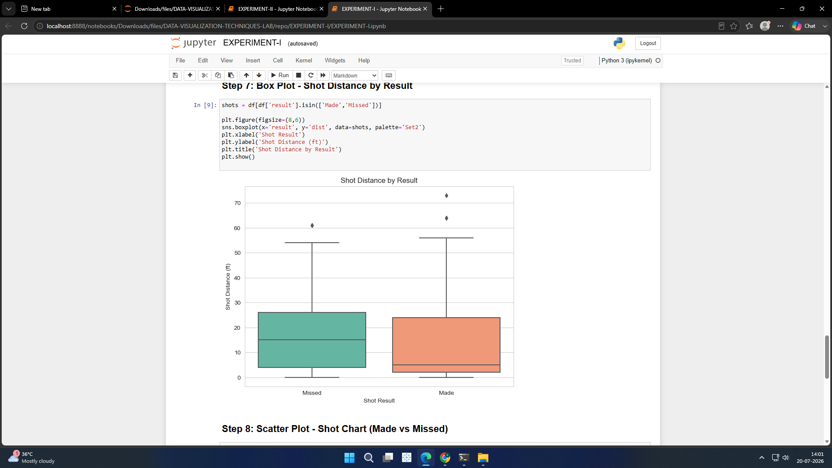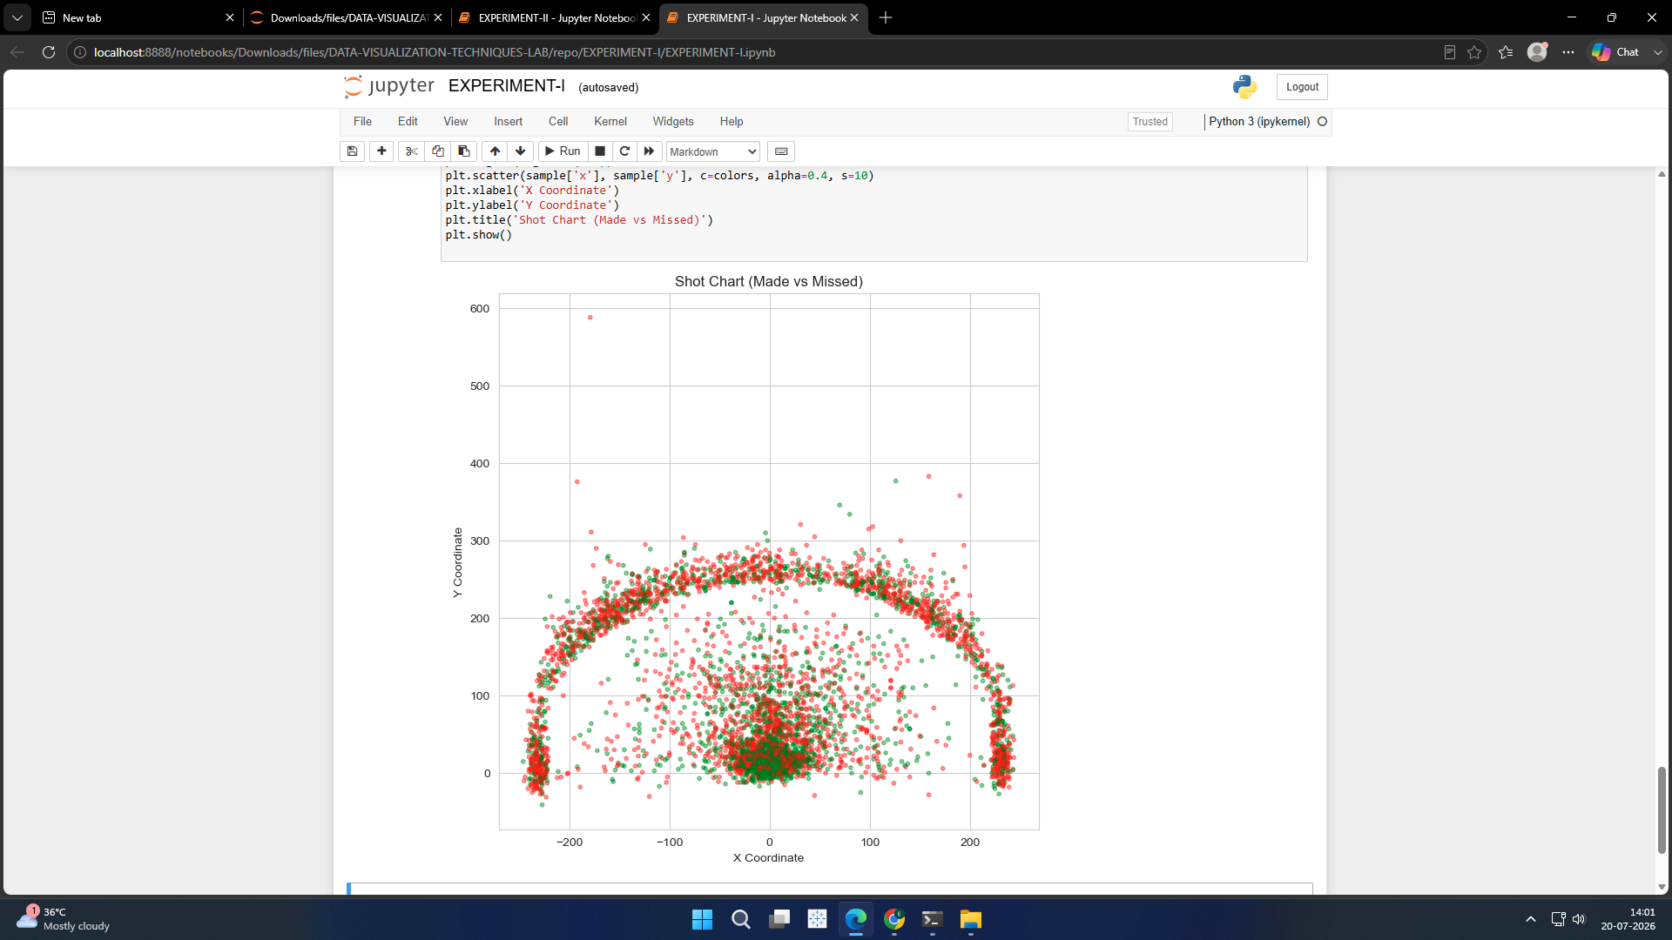

RESULT:
The Pandas DataFrame was successfully created, displayed, and verified, demonstrating the basic operations of data organization and manipulation using Python.

